LISVANE COMMUNITY COUNCIL
COMMUNITY COUNCILLOR VACANCY – CO-OPTION NOTICE
[Pursuant to Section 116 of the Local Government (Wales) Measure 2011]

COMMUNITY NAME: LISVANE |  |  | Community
WARD NAME: LISVANE |  |  | Ward  (if applicable)
NOTICE IS HEREBY GIVEN that TWO vacancies have arisen in the office of Councillor for the above mentioned Ward and Community, and the Community Council intends to co-opt to fill those vacancies.

LCC is a small Local Authority which aims to improve the quality of life of residents and also protect and develop the infrastructure of Lisvane. LCC takes a special interest in the level of services provided by the County Council, Health Authority Trusts, the Environment Agency and other public bodies. Planning applications affecting Lisvane receive special attention. LCC works closely with the Lisvane County Councillors and also, when appropriate, our MP and our Welsh Assembly Members. LCC is generally a non-political body.
Expressions of interest are being sought from members of the public who are interested in representing their community on the Community Council.

The Co-optee will be a local resident who is able to attend monthly evening meetings (2nd Monday of each month) and occasionally sub-committee/working party meetings. He or she will need to be able to work as part of a team but also feel able to express opinions freely. A range of training modules for new Community Councillors is run by One Voice Wales and any training fees will be met by LCC.

You must be a British, Commonwealth, Irish or European Union citizen and be 18 years of age or over; and meet at least one of the following criteria:

- Be (and remain) registered as a local government elector for the community named above;
- During the whole of the last 12 months have occupied, as owner or tenant, land or other premises in the community named above;
- Your principal or only place of work during the last 12 months has been in the community named above; or
- You have during the whole of the last 12 months resided in the community or within 3 miles of it.

Certain people are disqualified from standing, and these include paid officers of the community council, anyone subject to bankruptcy restriction orders and those subject to recent sentences of imprisonment. It is the responsibility of the candidate to ensure that they are qualified to stand.
If you wish to be considered for co-option for the vacant seats or would like more information regarding the role of a Community Councillor please contact:

Haydn Davies
Clerk to the Lisvane Community Council
7 Cherry Orchard Road
Lisvane
Cardiff
CF14 0UD
Email: clerk.lisvanecc@btinternet.com

Tel: 07979 530278

ON OR BEFORE 31 DECEMBER 2024

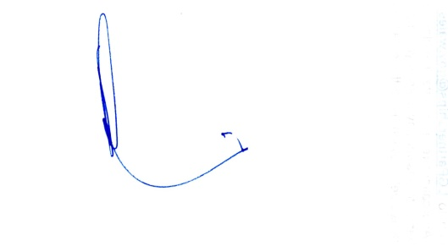

Signed Dated 4 November 2024
Clerk to the Council

