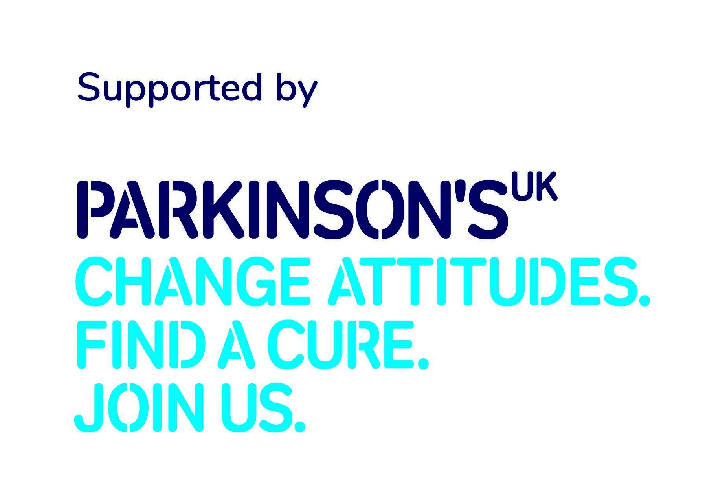
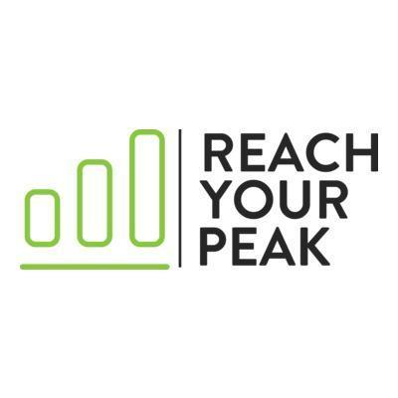

IMMEDIATE RELEASE

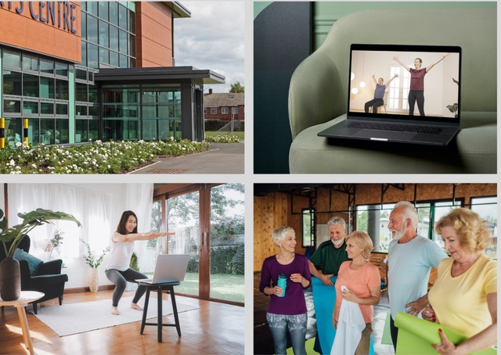
(Image credit: Reach Your Peak)

South Wales Parkinson’s community invited to Get Started with new hybrid workouts

People living with Parkinson’s in South Wales are being invited to try a new pilot hybrid workout class, called Get Started Local.

Organised by Cardiff-based physical activity provider, Reach Your Peak, and using specialist coaching from Parkinson’s trained physios, the sessions combine the best of online physical activity workouts with in-person classes at the local leisure centre in Llanrumney.

The first in-person session takes place on Thursday 11 April from 11am to 12pm at Eastern Leisure Centre, Llanrumney Avenue, Llanrumney, Cardiff, CF3 4DN.

Get Started Local is a 10-week series of online and in-person classes which are designed to help more people get active with Parkinson’s in a fun and engaging way.

The hybrid workout classes are being supported by grant funding from Parkinson’s UK and it is hoped that more people living with the condition in South Wales will be able to take advantage of the new offer.

Tim Morton, Physical Activity Programme Lead for Parkinson’s UK, said:

“We are delighted to continue our partnership with the team at Reach Your Peak and we hope that the new Get Started Local sessions will allow more people to get active with Parkinson’s and live well with the condition.

“Being active can be one of the best ways to help you manage your condition when you live with Parkinson’s and we want as many people living in Wales to take advantage of the new offer from Reach Your Peak.”

Maria Lewis, Chartered Physiotherapist at Reach Your Peak, said:

“We are delighted to be able to offer our new Get Started Local project which will help more people living with Parkinson’s to get active across Wales.

“Our specially trained fitness coaches and physios can work with you to help you make the most of the 10-week programme and all our workouts are designed around the needs of the individual. We can also help you to monitor your progress, show you how your active journey is going and give you the tools to enjoy being active with Parkinson’s.

“We also want more people to be able to access a community of like-minded participants who are active with Parkinson’s and we hope that Get Started Local will help more people living with the condition to feel good both inside and out.”

To register for the Get Started Local sessions, visit the Reach Your Peak website or contact reachyourpeakonline@mail.com.

ENDS

Media enquiries

For more information contact Claudia Christie, Senior Media and PR Officer at Parkinson’s UK on 020 7963 9379 or email cchristie@parkinsons.org.uk

About Parkinson’s and Parkinson’s UK

Parkinson’s is what happens when the brain cells that make dopamine start to die. There are more than 40 symptoms, from tremor and pain to anxiety. Some are treatable, but the drugs can have serious side effects. It gets worse over time and there’s no cure. Yet.
Parkinson’s is the fastest growing neurological condition in the world. Around 153,000 people in the UK have Parkinson’s.
We are Parkinson's UK. Here for everyone affected by the condition. Funding research into the most promising treatments, taking us closer to a cure every day. Fighting for fair treatment and better services.
Read more facts and statistics.
Further information, advice and support is available on our website, www.parkinsons.org.uk or our free, confidential helpline on 0808 800 0303.

About Reach Your Peak

Reach Your Peak is an online exercise and physical activity community that offers a range of workouts, activities and resources for the Parkinson’s community. Reach Your Peak delivers a range of tailored online workouts, activity classes and wellbeing resources.

People with Parkinson’s can benefit from the Get Started programme or choose from online Yoga, Pilates and dancing classes.

The online clinic gives people with Parkinson’s the tools and resources to manage their physical activity journey and monitor their progress through an online dashboard and the Reach Your Peak app.

People with Parkinson’s can also engage with Reach Your Peak community events, live classes, guest speaker events and coffee & chat sessions.

