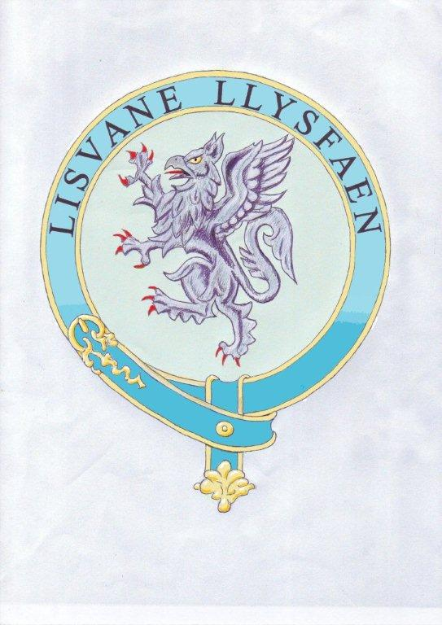

Lisvane Community Council

7 Cherry Orchard Road
Lisvane
Cardiff
CF14 0UD

Grant Application Form 2024-25
For grant applications of more than £250

Please note that statutory powers restrict which grants can be provided by the Council

Thank you for your enquiry about applying for a grant.

Please complete & return this application form with all supporting documentation to:

Clerk to the Council
Lisvane Community Council,
Cardiff CF14 0UD

Alternatively, you can submit the form via e-mail to clerk.lisvanecc@btinternet.com

If you would like assistance in completing this form or have any questions about it, please contact the Council on 07979 530278

- Name of organisation
- Contact Address
- Telephone number/ contact number
- Meeting Place or Venue (where your activities take place)
- Website (if any)
- Status of organisation | Charity |  |  |  | Other |  |  | Charity/Company number
- Date your organisation was established. (The Council would wish to be assured that any organisation we support is sustainable.)
- Contact Name

- Position (within organisation)
- What are the aims and objectives of your organisation
- Purpose for which the grant is sought
- How have you identified the need for this project
- Amount Requested

- For amounts of £500 or more please attach your last audited accounts.
- How will the project improve the quality of life for people who live in, work, or visit Lisvane
- What are the consequences of not undertaking this project?
- When will the project/activity start and finish?
- Who will benefit from the grant? (tick those which apply)

Adults
Older Adults
Children (up to 11)
Young people (12-18)
Men
Women
The whole community

- How many beneficiaries of the project/activity live or work in Lisvane? How have you come to this conclusion?

- Please explain how your project will reflect the social and cultural make-up of our community.
- For larger projects (ie total expenditure of £2,500 or more) please provide a full budget for the project, including how much you wish the Council to contribute. | Item |  |  | Total Cost |  |  |  | Amount Requested
Total
- How will you raise any outstanding balance?
- Have you made an application to other funders for this project/activity? Or do you intend to?  If so please tell us who they are, how much you have requested and when you expect a response. | Funder | Amount Requested |  |  |  | Amount Awarded |  |  | Response Date
- How will you measure the success of your project?

- In the event that your application is successful payment will be made by cheque – please advise the name of the payee:

- Your Committee | Chair |  |  |  | Treasurer |  |  | Secretary
- I confirm that the information contained within this form is correct and that I have attached the required documents | Name |  | Position |  |  |  | Signature |  |  | Date

Please return the completed application form and supporting documents to:

Lisvane Community Council,
7 Cherry Orchard Road, Lisvane, Cardiff CF14 0UD

Clerk – 07979 530278
Email: clerk.lisvanecc@btinternet.com

Where applicable, please include the following documents..

Please tick:

- Fully completed application form

- Evidence of cost (quotations)

- Accounts: for applications of £500.00 or more

- Copy of your organisation’s Governing Documents (Constitution, Terms of Reference )

- Equal Opportunities Policy.

- Safeguarding policy (if working with vulnerable adults)

- Child Protection Policy (if working with children/ young people)

If the Council award a grant, you will be required to include our logo on any promotional material etc and indicate that the Council has supported the activity. By accepting any grant, you must agree to the terms and conditions which will be set out in the grant acceptance letter.

You may also be required to complete a monitoring form to indicate how the money has been spent.

Details of how the Council use your information can be viewed at our website

For Office Use Only

Date application received
Decision
Minute Ref
Amount of grant
Date grant Paid
Cost Code

