THE VILLAGE TRAIL CHALLENGE
Friday 27 August 2021 – Monday 30 August 2021

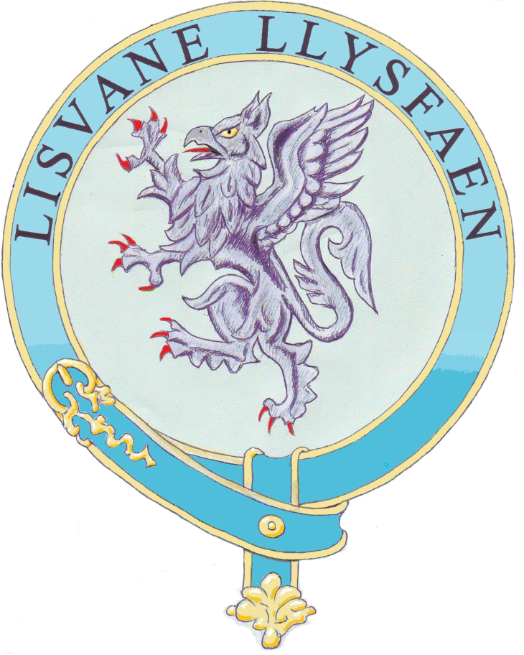

This challenge is based on The Lisvane Heritage Trail and is best completed if you buy the leaflet from Lisvane Stores (cost £1) as this includes a map of the route to follow. The start point is the car park at Cefn Onn Parc

Insert answers in the right hand column and return the completed form to:
7 Cherry Orchard Road, Lisvane, Cardiff, CF14 0UD or email to clerk.lisvanecc@btinternet.com by 1 September 2021

1. What colour are the round signs with white arrows showing you where to go?
2. How many bike racks are there in the car park?
3. What’s the telephone number for the Park Services?
4. Name the man who bought Cefn Onn Park for Cardiff Council in 1944?
5. The painting under the bridge includes the man who created the park – what was his name?
6. How many benches do you pass as you follow the route through the park?
7. How many men died building the railway tunnel?
8. At the end of the track before Graig Road do you go through a
a) 3 bar gate? b) 5 bar gate? c) 7 bar gate?
9. What’s the name of the house opposite the gate? (It means beautiful hill)
10. Just past the Ty Mawr, does the road sign warn you of
a) People on motorbikes? b) People on horses? c) People on tractors?
11. As you turn off Graig Road, what’s the colour of the water source?
12. How many gates do you go through between Graig Road and Llwyn-y-pia Road?
13. What is the name of 25 Llwyn-y-Pia Road?
14. When was the original Old School built?
15. Name the vicar of the Church of Saint Denys?
16. What is the total number of men from Lisvane who died in World War One and World War Two?
17. When did they finish building Lisvane Reservoir?
18. Look for the sign on Lisvane Road - what is the original Welsh name for Lisvane?
19. If you post a letter in Chartwell Drive, what time will the postman collect it on a Saturday?
20. What number is on the lamp post in Buckingham Close?
21. Not counting the telegraph pole, how many trees are there in front of the wall of the house called St. David’s on Mill Road?
22. Look carefully – what sort of bird is perched on a tree trunk in Old Mill Road?
23. There are two sets of steps as you follow the route through the woods – how many steps in total?
24. What does Coed-y-Felin mean in English?
25. Name the stream that flows through the woods.
26. What is the name of 18 Clos Llysfaen?
27. What colour are the bridge/ramp handrails and the warning markings on the platform in the railway station?
28. How many railway tracks are there?
29. How many feathers are there on the arch leading to Cefn Onn Park?
30. How far have you just walked in miles or kilometres?

The winner will receive a £25 Gift Card*

Completed by:

NAME………………………………………………………………………………

ADDRESS…………………………………………………………………………

EMAIL………………………………………………………………………………

TELEPHONE………………………………………………………………………

Neither Lisvane Community Council nor Lisvane Graig Protection Society will retain any personal details or use them for any other purpose. We accept no liability for damage, loss or injury of any nature during completion of the challenge and children should be accompanied by a responsible adult.
*In the event of a tie the winner will be chosen by a draw from the winning entries.

